Section I: Scenario Demographics

Scenario Title: | STEMI with Cardiogenic Shock
Date of Development: | 20/06/2015 (DD/MM/YYYY)
Target Learning Group: | Juniors (PGY 1 – 2) Seniors (PGY ≥ 3) All Groups

Section II: Scenario Developers

Scenario Developer(s): | Kyla Caners
Affiliations/Institution(s): | McMaster University
Contact E-mail (optional): | kcaners@gmail.com

Section III: Curriculum Integration

Learning Goals & Objectives
Educational Goal: | To practice managing cardiogenic shock, a relatively rare form of shock.
CRM Objectives: | - Communicate effectively with team members in the care of a complex, critically ill patient.  - Prioritize orders, medication administration, and airway management among team members appropriately.
Medical Objectives: | - Arrange urgent consultant care while managing a critically ill patient.  - Recognize and appropriately treat cardiogenic shock with inotropes.  - Demonstrate a safe approach to intubating a patient with cardiogenic shock.

Case Summary: Brief Summary of Case Progression and Major Events
A 55 year old man presents to the ED as a STEMI call. He is profoundly hypotensive with low O2 sats and obvious CHF. The patient’s blood pressure will transiently respond to fluid resuscitation. The ECG will show anterolateral ST elevation. The team will need to prepare for intubation while activating the cath lab. They will also need to start vasopressors. The patient will remain hypotensive until an inotrope like dobutamine is initiated. If unsafe medications are chosen for intubation, the patient will have a VT arrest.

References
Marx, J. A., Hockberger, R. S., Walls, R. M., & Adams, J. (2013). Rosen's emergency medicine: Concepts and clinical practice. St. Louis: Mosby.

Section IV: Scenario Script

A. Scenario Cast & Realism
Patient: | Computerized Mannequin |  |  |  |  | Realism:  Select most important dimension(s) |  |  | Conceptual
 | Mannequin |  |  |  |  |  |  |  | Physical
 | Standardized Patient |  |  |  |  |  |  |  | Emotional/Experiential
 | Hybrid |  |  |  |  |  |  |  | Other:
 | Task Trainer |  |  |  |  |  |  |  | N/A
Confederates | Brief Description of Role
Paramedic | Bag the patient during handover.
B. Required Monitors
EKG Leads/Wires |  |  | Temperature Probe |  |  |  | Central Venous Line
NIBP Cuff |  |  | Defibrillator Pads |  |  |  | Capnography
Pulse Oximeter |  |  | Arterial Line |  |  |  | Other:
C. Required Equipment
Gloves |  |  | Nasal Prongs |  |  |  | Scalpel
Stethoscope |  |  | Venturi Mask |  |  |  | Tube Thoracostomy Kit
Defibrillator |  |  | Non-Rebreather Mask |  |  |  | Cricothyroidotomy Kit
IV Bags/Lines |  |  | Bag Valve Mask |  |  |  | Thoracotomy Kit
IV Push Medications |  |  | Laryngoscope |  |  |  | Central Line Kit
PO Tabs |  |  | Video Assisted Laryngoscope |  |  |  | Arterial Line Kit
Blood Products |  |  | ET Tubes |  |  |  | Other:
Intraosseous Set-up |  |  | LMA |  |  |  | Other:
D. Moulage
Diaphoresis spray, older man mask.

E. Approximate Timing
Set-Up: |  | 3 min |  | Scenario: | 12 min |  |  | Debriefing: |  | 20 min

Section V: Patient Data and Baseline State

A. Clinical Vignette: To Read Aloud at Beginning of Case
A 55-year-old male presents to the ED with EMS as a STEMI activation. He arrives being bagged by EMS for hypoxia. His initial EMS call was for chest pain and he has significantly deteriorated en route. He has a history of smoking, hypertension, diabetes, and hypercholesterolemia. No prior cardiac history.
B. Patient Profile and History
Patient Name: John Hamilton |  |  |  |  |  | Age: 55 |  |  |  |  |  |  |  | Weight: 80kg
Gender: M F |  |  |  |  |  | Code Status: Full
Chief Complaint: Chest pain
History of Presenting Illness: Chest pain onset 2 hours prior. Called EMS and they found a STEMI on their field ECG. Patient then started becoming SOB and deteriorated on route.
Past Medical History: |  | HTN |  |  |  |  | Medications: |  |  |  |  | HCTZ 25mg daily
 |  | DM |  |  |  |  |  |  |  |  |  | Metformin 500mg TID
 |  | Dyslipidemia |  |  |  |  |  |  |  |  |  | Lipitor 40mg daily
 |  |  |  |  |  |  |  |  |  |  |  | Ramipril 5mg daily
Allergies: None.
Social History: Smoker.
Family History: No family history CAD.
Review of Systems: |  | CNS: |  |  | Patient too hypoxic/altered. Unable.
 |  | HEENT: |  |  | Patient too hypoxic/altered. Unable.
 |  | CVS: |  |  | Patient too hypoxic/altered. Unable.
 |  | RESP: |  |  | Patient too hypoxic/altered. Unable.
 |  | GI: |  |  | Patient too hypoxic/altered. Unable.
 |  | GU: |  |  | Patient too hypoxic/altered. Unable.
 |  | MSK: |  |  | Patient too hypoxic/altered. |  |  |  |  |  |  |  | INT: |  | Unable.
C. Baseline Simulator State and Physical Exam
No Monitor Display |  |  |  | Monitor On, no data displayed |  |  |  |  |  |  | Monitor on Standard Display
HR: 110/min |  |  | BP: 80/40 |  |  |  |  | RR: 30/min |  |  |  |  |  |  | O₂SAT: 85% BVM
Rhythm: Sinus tach |  |  | T: 36.2ºC |  |  |  |  | Glucose: 6.2 mmol/L |  |  |  |  |  |  | GCS: 10 (E3 V2 M5)
General Status: Cool, clammy, looks unwell.
CNS: | Non-verbal. Depressed LOC.
HEENT: | Nil.
CVS: | No murmur.
RESP: | Diffuse crackles to apices.
ABDO: | Soft, NT.
GU: | Nil.
MSK: | Nil. |  |  |  |  |  |  |  | SKIN: | Cool, clammy, mottled.

Scenario States, Modifiers and Triggers
Patient State | Patient Status | Learner Actions, Modifiers & Triggers to Move to Next State
1. Baseline State  Rhythm: sinus tach  HR: 110/min  BP: 80/40  RR: 30/min  O₂SAT: 85% BVM  T: 36.2ºC | Looks moribund. Cool, clammy, mottled skin. GCS 10 (E3 V2 M5). | Learner Actions  - IV access, O2, monitors  - ECG (STEMI)  - Blood work  - Trial 250-500ml NS bolus  - Check cap sugar (6.2)  - Prepare for intubation  - Call cath lab (they will be delayed 30 min) | Modifiers  Changes to patient condition based on learner action  - Bolus given BP 85/45  - 5 minutes desat to 80%  Triggers  For progression to next state  - Intubation 2. Intubation
2. Intubation  As above. | As above. | Learner Actions  - Consider bipap as bridge  - Pre-medicate with fentanyl  - Induction with etomidate or ketamine  - Use of paralytic  - Vasopressor at bedside  - PEEP valve ready | Modifiers  Triggers  - Propofol used or unsafe intubation 3. VT arrest  - Intubation safe 4. Ongoing hypotension
3. VT arrest  Rhythm VT  HR 180  BP ?/? | Patient pulseless and unresponsive. | Learner Actions  - High quality CPR.  - Defibrillate VT.  - Amiodarone 300mg iv  - Epinephrine 1mg iv q3min | Modifiers  Triggers  - 2 cycles CPR 4. Ongoing hypotension
4. Ongoing hypotension  HR 120  BP 70/30  O₂SAT 92% on 100% | Intubated and sedated. | Learner Actions  - CXR (post-intubation)  - Sedation  - OG insertion to facilitate giving ASA and ticagrelor  - Heparin 4000 units iv  - Call cath lab again  - Start norepi infusion at 0.05-2 mcg/kg/min and titrate up  - Start dobutamine infusion at 2.5mcg/kg/min  - Consider another 500ml NS | Modifiers  - Dobutamine started 1st BP 50/10  - Norepi started BP 75/35  - Norepi titrated up 2-3 times BP 85/45  - Dobutamine added BP 90/55  Triggers  - 12 min 5. Stabilization  - Vasopressor & inotrope started 5. Stabilization
5. Stabilization  HR 100  BP 95/65  O₂SAT 92% on 100% | As above. | Learner Actions  - Finish tasks from above | Cath lab calls to say they are ready for the patient.  END CASE
Section VI: Scenario Progression

Section VII: Supporting Documents, Laboratory Results, & Multimedia

Laboratory Results
No lab results required for this case.

Images (ECGs, CXRs, etc.)
ECG – anterolateral STEMI  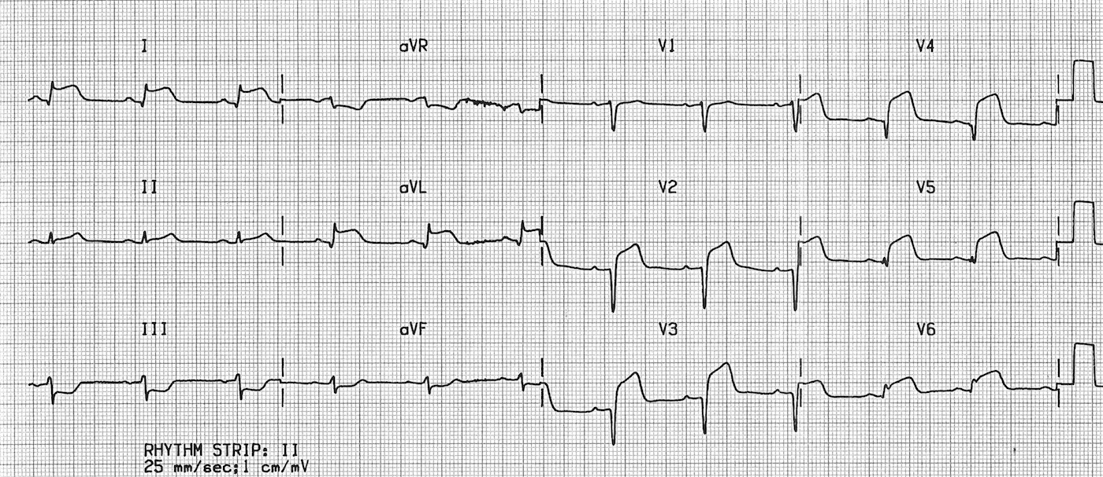  ECG source: https://lifeinthefastlane.com/ecg-library/lateral-stemi/ | CXR – CHF (pre-intubation)  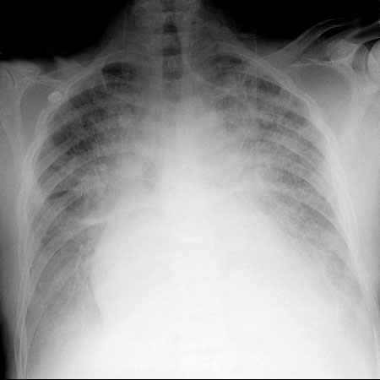  CXR source: https://www.med-ed.virginia.edu/courses/rad/cxr/pathology2Bchest.html
CXR – CHF (post-intubation)
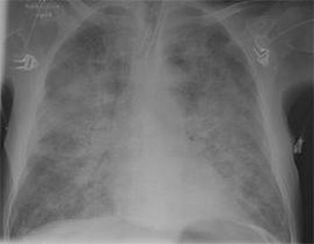
CXR source:
https://heart-conditions.knoji.com/learning-about-and-coping-with-congestive-heart-failure/
Ultrasound Video Files (if applicable)
Echo showing RWMA | Lung U/S – pulmonary edema

Section VIII: Debriefing Guide

General Debriefing Plan
Individual | Group |  | With Video | Without Video
Objectives
Educational Goal: |  | To practice managing cardiogenic shock, a relatively rare form of shock.
CRM Objectives: |  | - Communicate effectively with team members in the care of a complex, critically ill patient.  - Prioritize orders, medication administration, and airway management among team members appropriately.
Medical Objectives: |  | - Arrange urgent consultant care while managing a critically ill patient.  - Recognize and appropriately treat cardiogenic shock with inotropes.  - Demonstrate a safe approach to intubating a patient with cardiogenic shock.
Sample Questions for Debriefing
- What did you see as the priorities for this patient’s management on presentation? How did you juggle these and decide which came first?
- Describe the team dynamic and communication in the room. Do you feel the patient got everything he needed? Was the environment calm?
- Do you have an approach to treating cardiogenic shock?
- Do you have an approach to intubating a patient with cardiogenic shock? What are some of the risks/benefits of the different agents available for induction? What else is important to consider as your prepare for intubation in this patient? What equipment should you have available?
Key Moments
Intubation.
Activation of cath lab.
Treatment of cardiogenic shock.

